CONFIDENTIAL CS/OCT 2026/MAT133

UNIVERSITI TEKNOLOGI MARA FINAL EXAMINATION

COURSE
COURSE CODE
EXAMINATION TIME
PRE CALCULUS
MAT133 OCTOBER 2026
2 HOURS

INSTRUCTIONS TO CANDIDATES

- This question paper consists of 5 questions.

- Answer ALL questions in the Answer Booklet. Start each answer on a new page.

- Do not bring any material into the examination room unless permission is given by the invigilator .
- Please check to make sure that this examination pack consists of: i) the Question Paper
  - a one - page Append ix 1
  - an Answer Booklet - provided by the Faculty
  - a graph paper - provided by the Faculty

- Answer ALL questions in English.

/

DO NOT TURN THIS PAGE UNTIL YOU ARE TOLD TO DO SO

This examination paper consists of 6 printed pages

QUESTION 1
a) Solve the inequality -2x² + 4x + 16 > 0.
(5 marks)
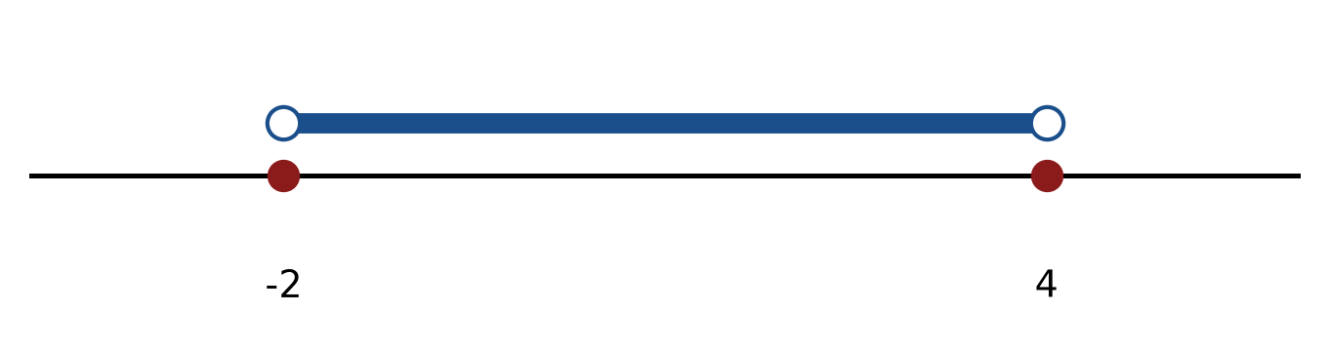
Figure: critical values.
b) Solve the inequality |-5x - 3| < 3. Express the answer in interval notation and on a number line.
(5 marks)
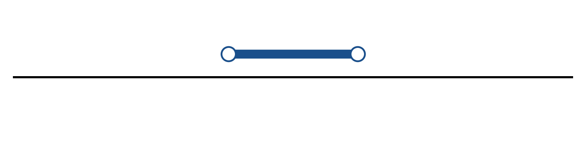
Figure: solution on a number line.
c) Sketch y = 2|x - 4| - 4. State the vertex, the y-intercept and any x-intercepts.
(5 marks)
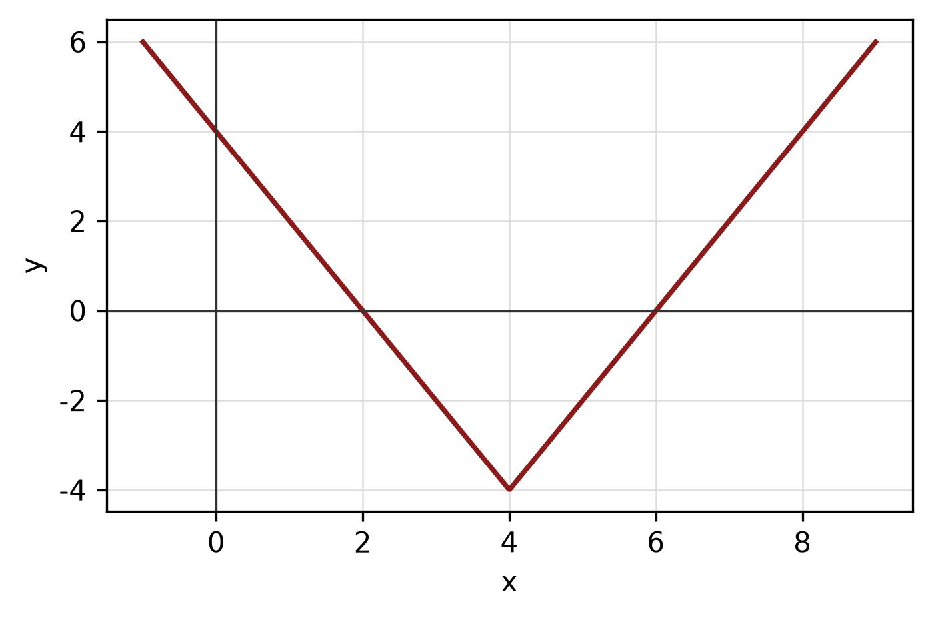
Figure: absolute-value graph.
QUESTION 2
a) Given f(x) = (4x - 2)/(3x + 6), x ≠ -2, find f⁻¹(x) and state its domain.
(5 marks)
b) The piecewise function is defined by
f(x) = 4x + 1, if x < -1;
f(x) = 1, if -1 ≤ x ≤ 2;
f(x) = x² + 4, if x > 2.
Sketch the graph and find f(-2), f(0) and f(3).
(5 marks)
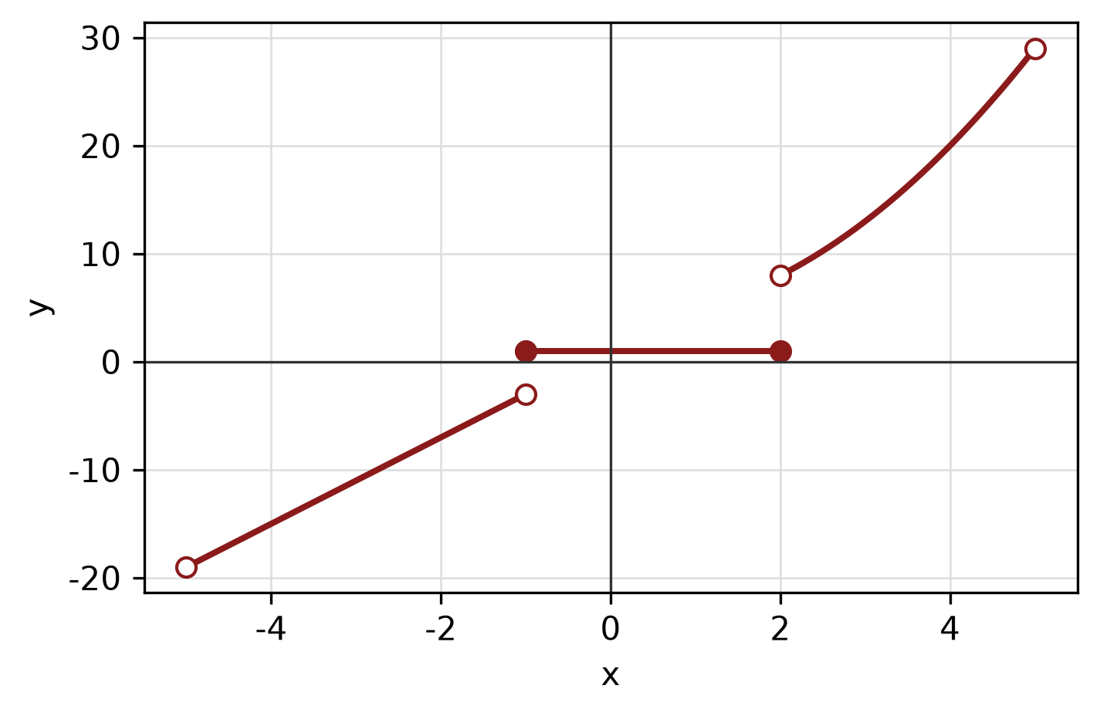
Figure: piecewise graph.
c) The endpoints of a diameter of a circle are (-1, -5) and (-6, -3). Find the centre, radius and equation of the circle.
(5 marks)
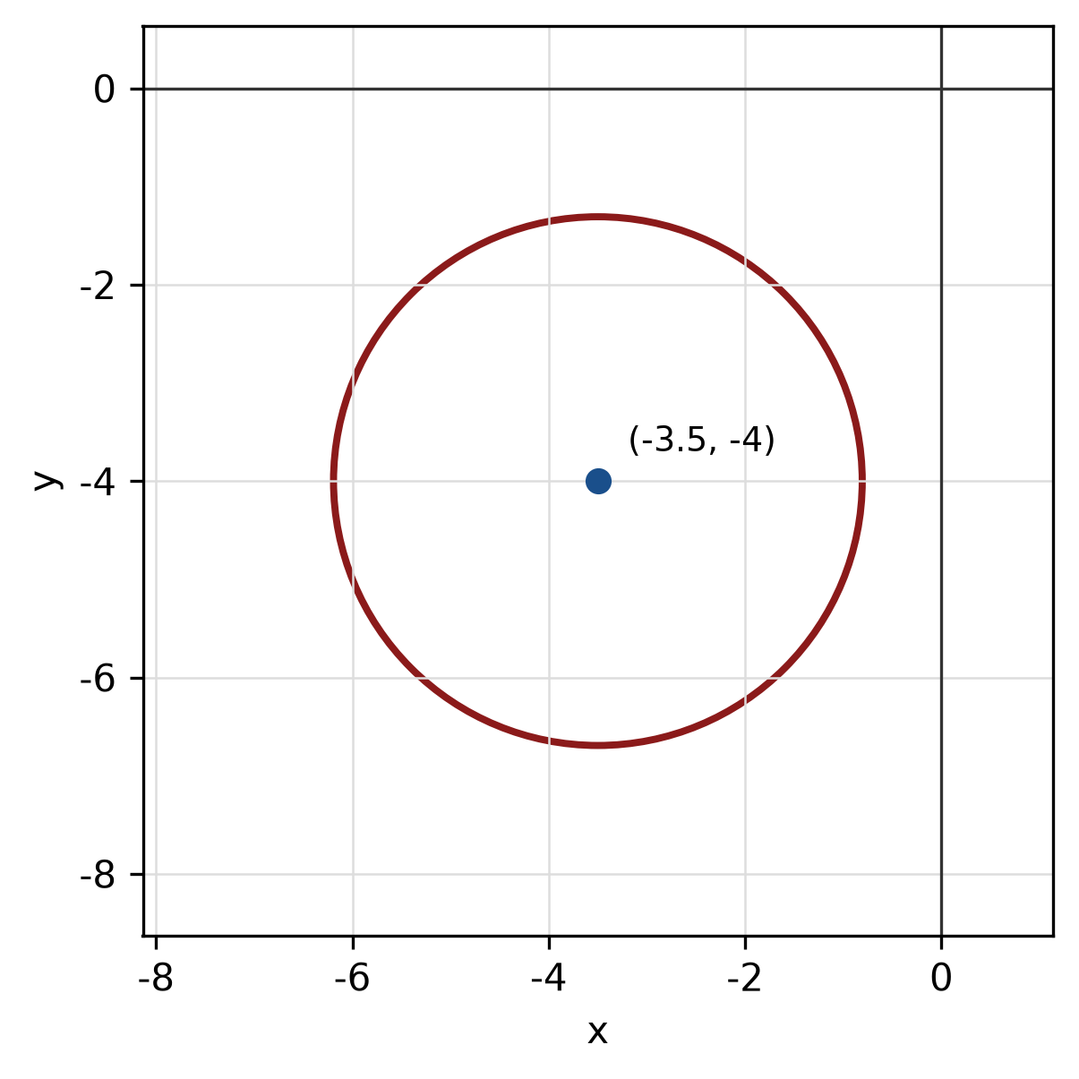
Figure: circle from diameter.
QUESTION 3
a) Given z₁ = -4 + 5i and z₂ = -1 - 2i, express z₁/z₂ in the form a + bi.
(5 marks)
b) Find the modulus and argument of z = 5 + 12i. Give the argument in degrees correct to one decimal place.
(5 marks)
c) Solve the logarithmic equation log_2(x) + log_2(x - 31) = 5.
(5 marks)
QUESTION 4
a) Graph the system of inequalities below and shade the feasible region. State the vertices of the region.
x ≥ 0, y ≥ 0, 3x + 3y ≤ 8.
(5 marks)
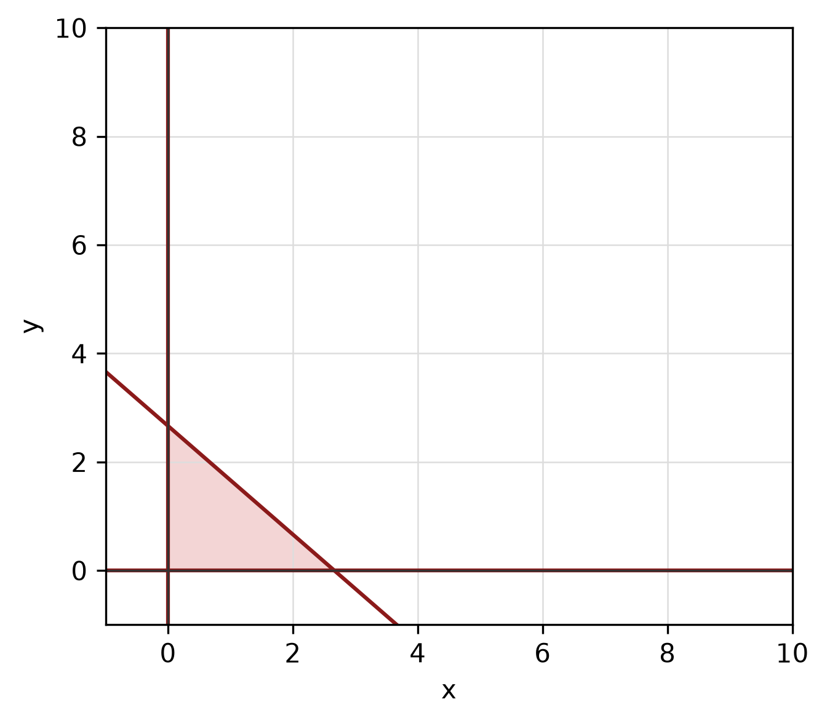
Figure: feasible region.
b) Solve the simultaneous equations
-x + 3y = 0
-3x - y = -10.
(4 marks)
c) Write y = x²/8 + x/4 - 15/8 in standard form. Hence state the vertex, focus and directrix, and sketch the parabola.
(5 marks)
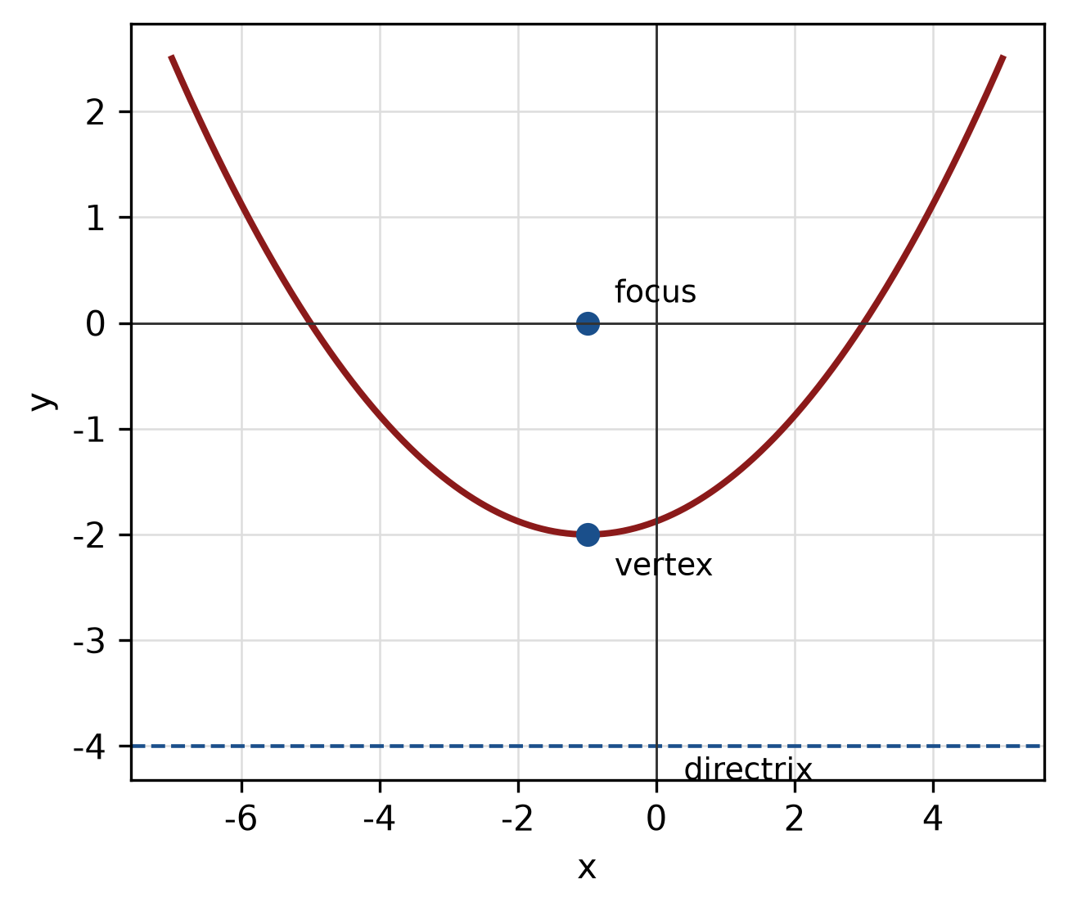
Figure: parabola.
QUESTION 5
a) Prove the identity sin² x/(1 - cos x) = 1 + cos x.
(5 marks)
b) A circle has radius 10 cm. Find the length of the arc subtended by a central angle of 135°.
(4 marks)
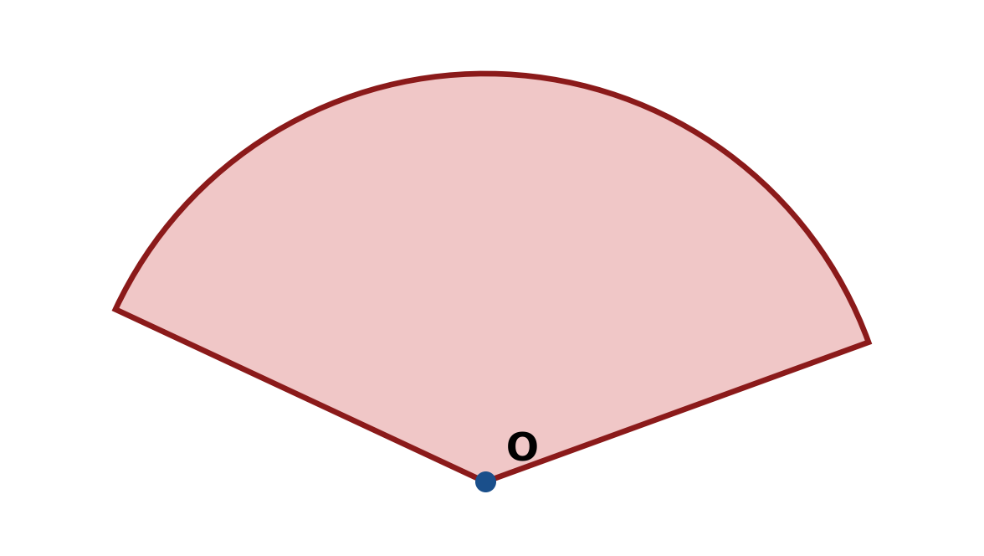
Figure: arc and sector.
c) Find the area of triangle ABC with a = 7 cm, b = 6 cm and included angle C = 30°.
(4 marks)
END OF QUESTION PAPER

APPENDIX 1
Formula sheet (as supplied with the paper).
sin² A + cos² A = 1 | tan² A + 1 = sec² A
sin(A + B) = sin A cos B + cos A sin B | tan 2A = 2 tan A / (1 − tan² A)
cos(A + B) = cos A cos B − sin A sin B | Arc length, s = rθ
tan(A − B) = (tan A − tan B) / (1 + tan A tan B) | Area of sector = ½r²θ
cos 2A = cos² A − sin² A | a / sin A = b / sin B = c / sin C
cos 2A = 1 − 2sin² A = 2cos² A − 1 | a² = b² + c² − 2bc cos A
sin 2A = 2 sin A cos A | Area of triangle = ½ab sin C

